Project Design Phase-II
Technology Stack (Architecture & Stack)

Date | 15 February 2026
Team ID | LTVIP2026TMIDS26598
Project Name | Prevent User Deletion If Assigned to Incident
Maximum Marks | 4 Marks

Technical Architecture:
The solution is implemented inside the ServiceNow platform using:
- ServiceNow Instance (Cloud Platform)
- sys_user Table
- Incident Table
- Business Rule (Before Delete)
- GlideRecord Script Logic
- Role-based Access Control
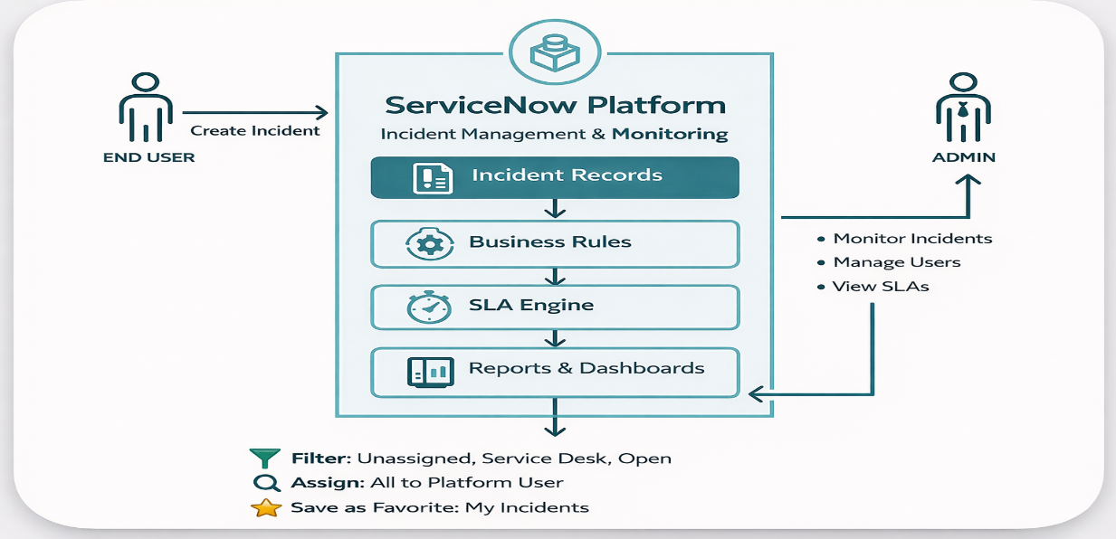

Table-1 : Components & Technologies:
S.No | Component | Description | Technology
 | User Interface | Interface to manage users and incidents | ServiceNow UI
 | Business Logic | Prevent user deletion if assigned to incident | Business Rule (Before Delete Script)
 | Data Source | User and Incident records | sys_user table, incident table
 | Database | Stores all records | ServiceNow Cloud Database
 | Script Engine | Executes server-side logic | GlideRecord, JavaScript
 | Access Control | Restrict deletion permissions | ACL (Access Control List)
 | Notifications | Optional alerts for deletion attempts | ServiceNow Notification Engine
 | Infrastructure | Cloud-based ITSM platform | ServiceNow Cloud Instance.
 | Logging | Tracks deletion attempts | System Logs
 | Development Platform | Platform used to configure logic | ServiceNow Studio / Global Scope

Table-2: Application Characteristics:
S.No | Characteristics | Description | Technology
 | Open-Platform | Built using ServiceNow scripting framework | JavaScript (Server-side)
 | Security | Prevents accidental deletion of active users | Role-based Access + Business Rule
 | Scalable | Can handle thousands of users & incidents | ServiceNow Cloud Infrastructure
 | Availability | Available 24/7 via cloud | ServiceNow SaaS Platform
 | Performance | Executes deletion validation instantly | GlideRecord Optimized Query

